HR ANALYSIS

OVERIVIEW
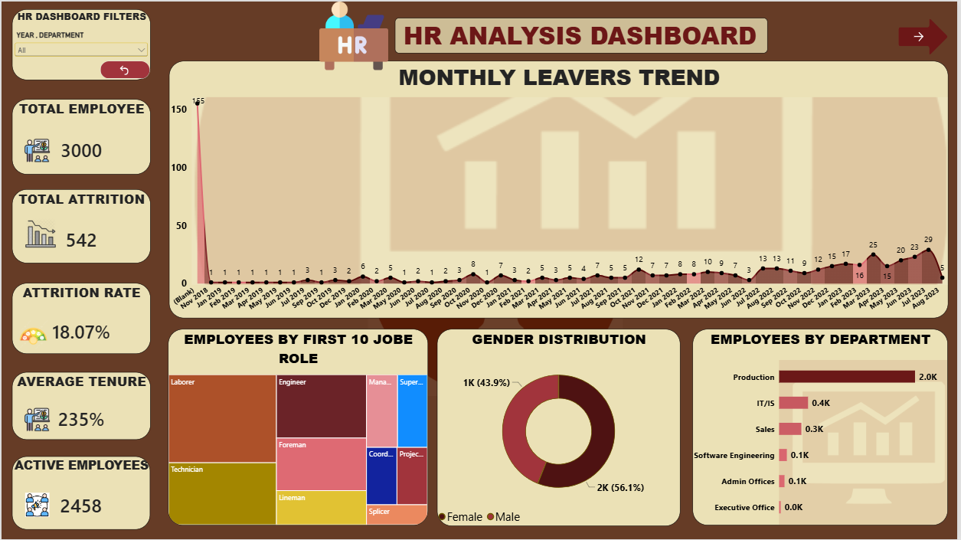

EMPLOYEE ENGAGEMENT AND PERFORMANCE
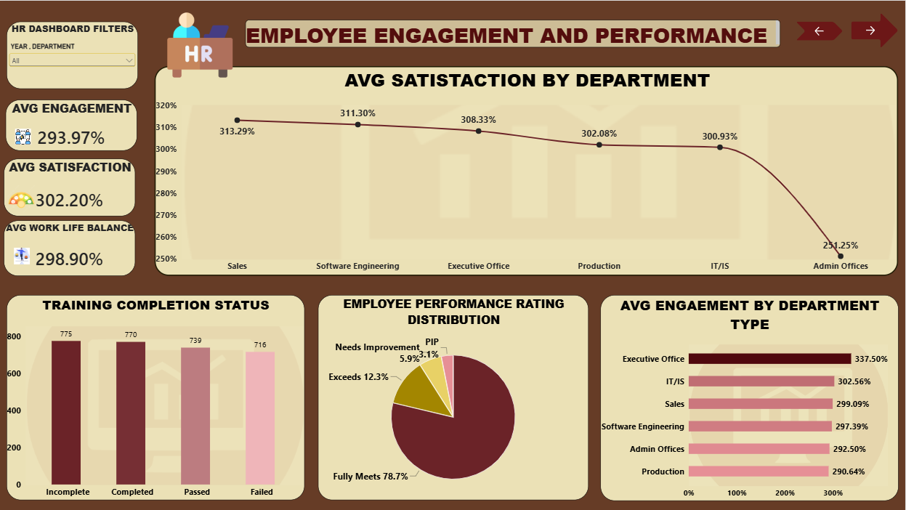
TRAINING AND RECRUITMENT
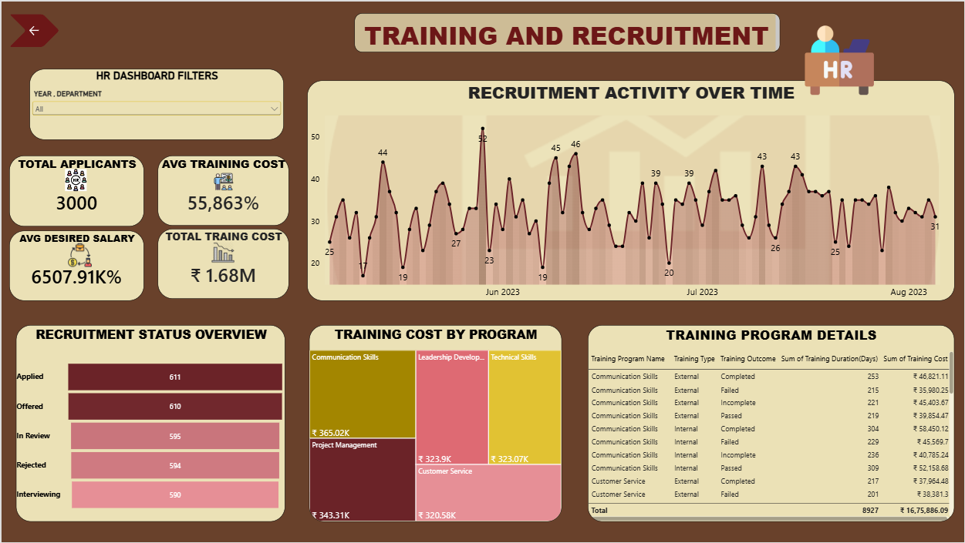

MODEL VIEW


